INFANT JESUS COLLEGE OF ENGINERING
Kamarajar Nagar, Tirunelveli-Thoothukudi Highway (NH-7A), Keelvallanadu
Thoothukudi District-628 851, TamilNadu.

PROJECT REPORT

Submitted by

Ramalakshmi . N - 951022104011
Hepziba Glory. T – 951022104003
Veerachandru . R – 951022104013
Ananth. P – 951022104301

In partial fulfilment for the academic

of

BACHELOR OF SCIENCE

IN

COMPUTER SCIENCE AND ENGINEERING

Educational Organisation Using Service now

Date | 2nd November 2025
Team ID | NM2025TMID02535
Project Name | Educational Organisation Using ServiceNow
Maximum Marks | 4 Marks

Abstract :
The project “Educational Organization Management using ServiceNow” aims to automate and streamline the administrative and academic operations of an educational institution. The system is developed on the ServiceNow platform, leveraging its low-code environment to create customized tables, workflows, and data relationships.
Three major modules — Salesforce, Admission, and Student Progress — were designed and implemented to manage student records, admissions, and academic performance efficiently. The Salesforce table stores core student and parent details, serving as a reference for other modules. The Admission table manages student admission data and links seamlessly with Salesforce for data consistency. The Student Progress table tracks subject-wise marks, averages, and results, enabling easy monitoring of academic performance.
By automating manual paper-based processes, the project reduces data redundancy, enhances accuracy, and improves accessibility for administrators, faculty, and students. The system provides a centralized and user-friendly digital solution that simplifies institutional management and supports effective decision-making.

Team Gathering, Collaboration and Select the Problem Statement

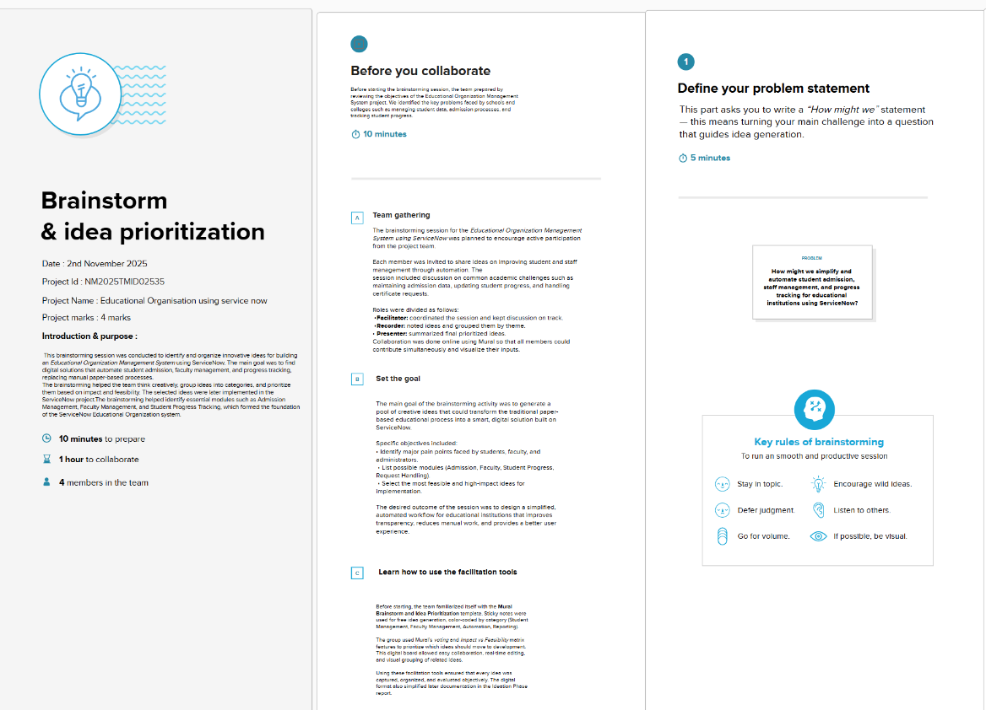

Brainstorm, Idea Listing and Grouping: 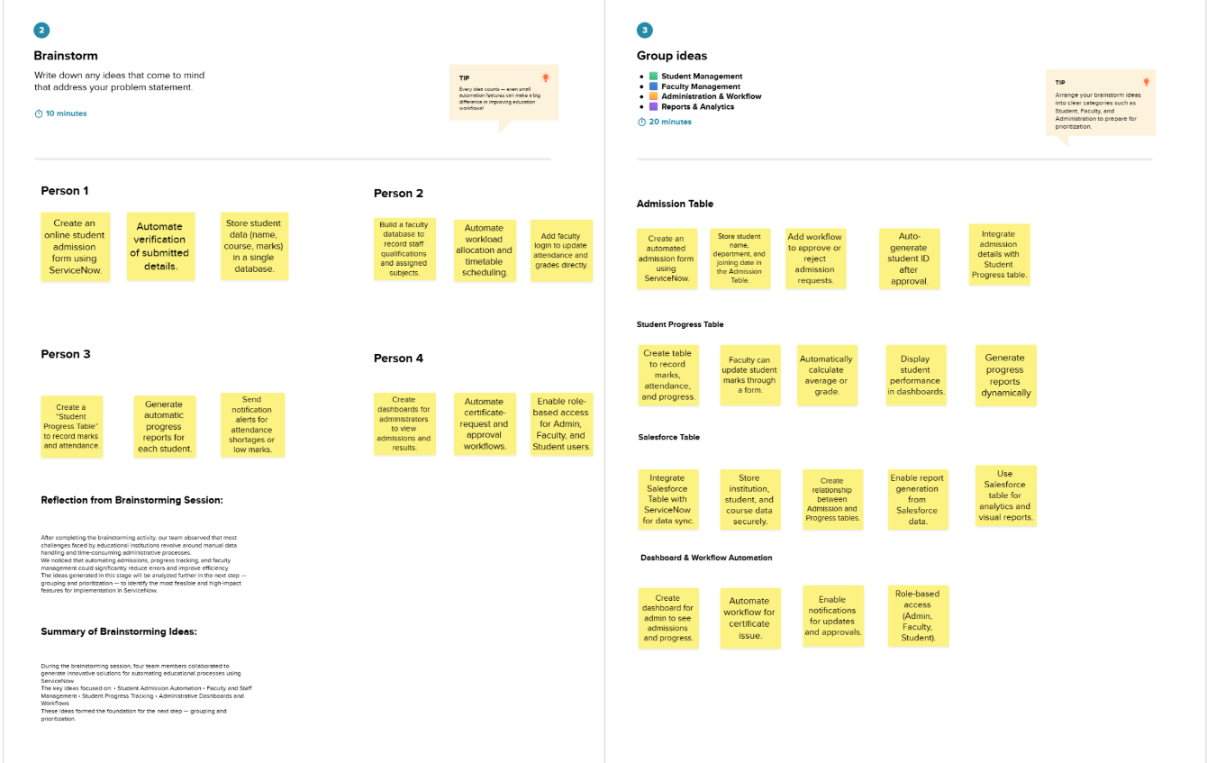

Idea Prioritization:
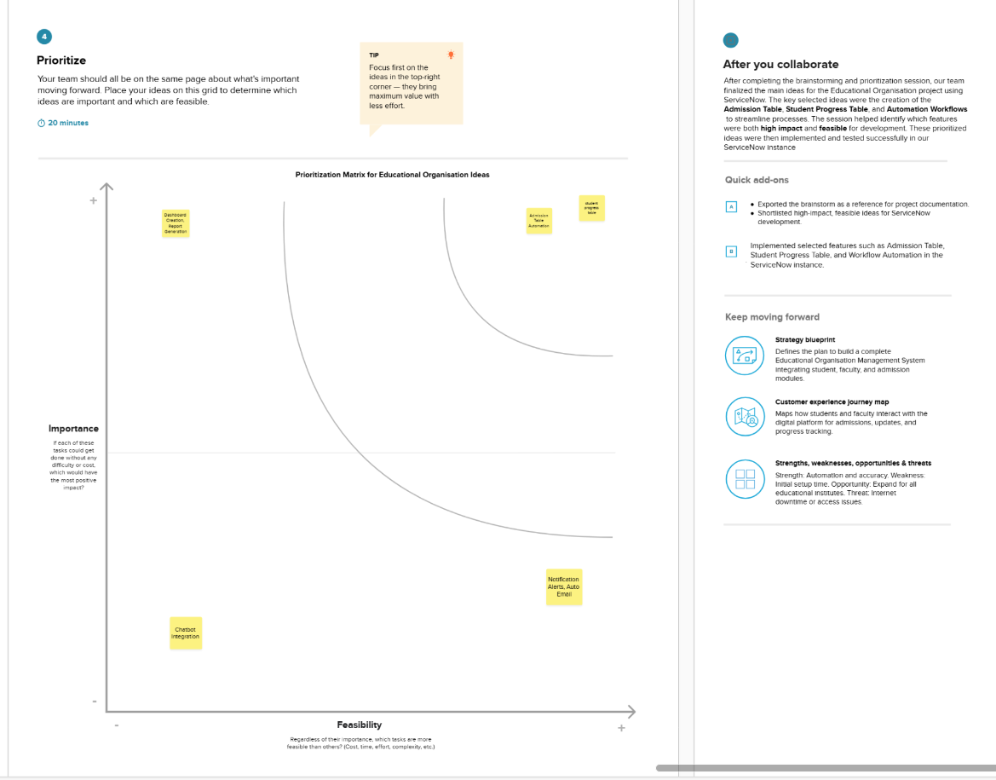

Objectives:
The education sector relies heavily on accurate data management for handling student information, admissions, and academic progress. Traditional manual record-keeping systems are time-consuming, prone to human errors, and make it difficult to maintain large volumes of data efficiently. To address these challenges, this project titled “Educational Organization Management using ServiceNow” was developed to automate and simplify these processes through a cloud-based digital platform.
ServiceNow, a powerful platform-as-a-service (PaaS), provides the flexibility to design and deploy custom applications without extensive coding. Using its table-based data management structure, the project integrates multiple modules to support different academic functions within an institution.
The system includes three major components:
- Salesforce Table – stores core student and parent details such as name, contact information, class, and admission number.
- Admission Table – records admission details, area, city, fee, and grade information, while referencing the Salesforce table for consistency.
- Student Progress Table – maintains student performance data, including marks in various subjects, average, percentage, and result.
This digital solution provides an efficient way to manage student-related data in real-time, reduce duplication, and allow easy retrieval for analysis and reporting. Overall, the project demonstrates how automation through ServiceNow can improve efficiency, transparency, and decision-making in educational institutions.
Existing System:
In most educational institutions, student data such as admission details, parent information, and academic progress are still maintained manually using paper records or basic spreadsheets. This traditional approach often leads to:
- Manual Errors: High chances of mistakes in data entry and record maintenance.
- Time Consumption: Staff need to spend long hours managing admissions and results.
- Data Redundancy: The same information is recorded multiple times across departments.
- Lack of Accessibility: Retrieving or updating specific student information is difficult and slow.
- No Automation: Processes like admissions approval, progress calculation, and reporting require manual intervention.
- Limited Data Security: Physical files or local systems are vulnerable to loss, damage, or unauthorized access.
Overall, the existing manual system lacks automation, reliability, and efficiency, making it unsuitable for modern digital education management.

Proposed System:
The Educational Organization Management System using ServiceNow replaces manual data handling with an automated, centralized, and digital platform.
This system allows administrators, teachers, and staff to efficiently manage all operations from admissions to performance tracking within one unified platform.
The proposed system includes:Automated Table-Based Data Management:
Three main tables — Salesforce, Admission, and Student Progress — handle all data digitally and connect via reference fields to maintain consistency.
- Workflow Automation:
Approval processes, record creation, and grade calculations are automated to save time and reduce human error.
- Centralized Database:
All student records are stored in one place, accessible securely from anywhere through the ServiceNow cloud.
- Quick Access and Reporting:
Administrators can instantly retrieve data and generate performance or admission reports.
- Improved Accuracy and Security:
Data duplication is eliminated, and access permissions ensure only authorized users can modify sensitive information.
- Scalable and Customizable:
The system can easily be extended with new modules, dashboards, and analytics features as needed.

System Design and Architecture:
The Educational Organization Management System is designed using the ServiceNow Platform, which allows table-based data management, automation through workflows, and relationship mapping between different modules.
The system is structured around three major tables — Salesforce Table, Admission Table, and Student Progress Table — that together form the backbone of the educational management application.
The design follows a modular and relational architecture, meaning each table performs a specific function but remains connected through Reference Fields to ensure smooth data flow and consistency.
Salesforce Table (Master Table):
The Salesforce Table acts as the primary database of the entire system.
It stores the main student and parent details and serves as a reference point for all other modules.
Key Features:
- Centralized repository for student information.
- Acts as the parent table for Admission and Student Progress modules.
- Prevents data duplication and ensures that all tables share consistent information.
Main Fields:
Student Name, Admin Number, Class, Grade, Father Name, Mother Name, Contact Numbers, Created by, Updated by. 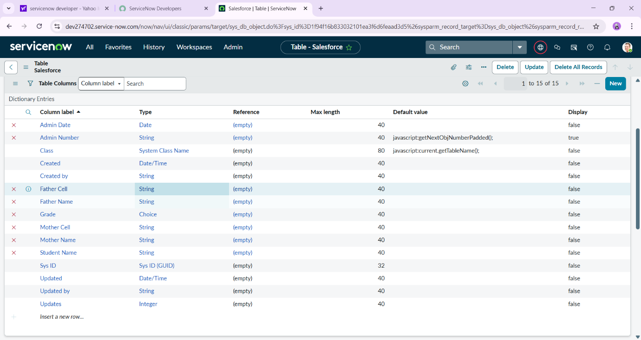

Admission Table :
The Admission Table handles the student admission process digitally.
It references the Salesforce Table through a field called Admission Number, which links each admission record to an existing student record.
Key Features:
- Automates admission record creation and approval.
- Includes choice fields like Status (Pending, Approved, Rejected) to track the admission process.
- Stores address, fee, and grade details for each student.
Main Fields:
Admission Number (Reference), Admin Status, Fee, Area, City, District, Father/Mother, Information, Comments, Admission Date 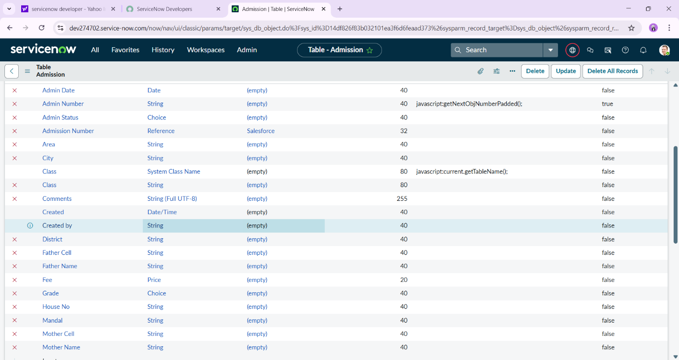
Student Progress Table :
The Student Progress Table is designed to track each student’s academic performance.
It is linked to the Salesforce Table using the Admission Number field to automatically fetch student details like name and admission date.

Key Features:
- Stores subject-wise marks (Maths, English, Science, etc.).
- Calculates average, percentage, and grade automatically.
- Generates academic performance reports for faculty and admin users.
Main Fields:
Admission Number (Reference), Subjects (Telugu, English, Maths, Science, Social, Hindi), Average, Percentage, Result, Grade.
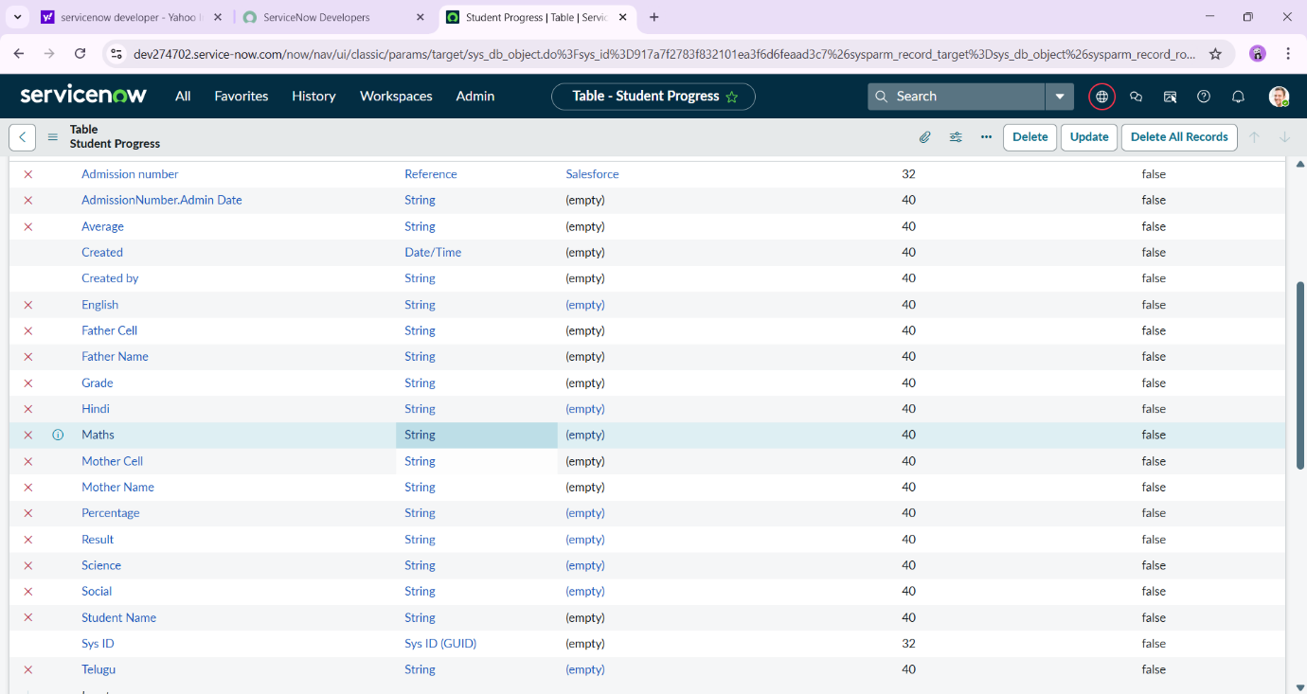
Implementation Steps:
The project “Educational Organization Management using ServiceNow” was implemented step by step in the ServiceNow Developer Instance.
Each step was carefully executed to create tables, forms, and automation rules that together make up the complete educational management system.
Step 1: ServiceNow Developer Instance Setup
- Logged into the ServiceNow Developer Portal and activated a personal developer instance.
- Verified system settings and configured the instance for application creation.
- Ensured admin access to all features like Table Creation, Client Scripts, and Business Rules.
Purpose:
To provide a secure and controlled environment for building and testing the application.
Step 2: Creating an Update Set
- Created a new Update Set to track all changes made during development.
- Named it “Educational_Organization_Project”.
- Every modification such as new tables, columns, and scripts was captured in this set.
Purpose:
To maintain version control and allow smooth migration or rollback of configurations.
Step 3: Creating the Salesforce Table
- Opened System Definition → Tables → New.
- Named the table Salesforce.
- Added fields like Student Name, Father Name, Mother Name, Admin Number, Contact Details, and Grade.
Saved and verified table structure.
Outcome:
This table serves as the master table storing primary student and parent details.
Step 4: Creating the Admission Table
- Created a new table named Admission under System Definition → Tables → New.
- Added important columns such as Admin Date, Admin Status, Area, City, District, Fee, and Comments.
- Linked the table with Salesforce through a Reference field called Admission Number.
- Created choice fields for Admission Status (Pending, Approved, Rejected).
Outcome:
Automated digital storage of student admission details and status tracking.
Step 5: Creating the Student Progress Table
- Created a table named Student Progress.
- Added subject fields: English, Telugu, Hindi, Maths, Science, Social.
- Included calculated fields such as Average, Percentage, and Result.
- Used a Reference field to link with Salesforce for automatic student detail fetching.
Outcome:
A complete academic tracking module for calculating grades and performance reports.
Step 6: Designing Form Layouts and Views
- Opened each table (Salesforce, Admission, Student Progress).
- Modified the Form Layout to group related fields logically — for example, separating Student Info, Parent Info, and Address.
- Configured List Views to show only the most relevant columns like Name, Grade, and Status.
- Set up Form Sections for better readability.
Purpose:
To ensure that the user interface is simple, clean, and easy to navigate for staff and administrators.
Step 7: Creating Choice Fields and Reference Links
- Added choice fields for Grade, Status, and Department to maintain uniformity.
- Established Reference Fields between tables:
  - Salesforce → Admission (Admission Number)
  - Salesforce → Student Progress (Admission Number)
- Verified the data flow between tables to ensure consistent record mapping.
Outcome:
Smooth data linkage and automatic fetching of related student records across modules.
Step 8: Implementing Business Rules and Client Scripts
- Created Business Rules to automate status updates when a new record is submitted.
- Used Client Scripts to validate data entry fields, ensuring no blank or incorrect values are saved.
- Tested rules using sample records to confirm correct behavior.
Example:
When Admission Status = “Approved”, send an automated confirmation to the admin.
Step 9: Testing and Validation
- Entered sample records into each table.
- Tested connections between tables and confirmed that updates in Salesforce reflected automatically in Admission and Progress tables.
- Checked calculated fields for accuracy (e.g., Grade and Percentage in Student Progress).
- Resolved minor validation issues and finalized forms.
Step 10: Output Verification
- Verified that all three modules worked together as a single system.
- Generated sample admission and progress reports for testing.
- Captured screenshots of Salesforce, Admission, and Student Progress tables for documentation.
Outcome:
A fully functional educational management system built using ServiceNow’s table-based architecture and automation tools.

Output:
Salesforce: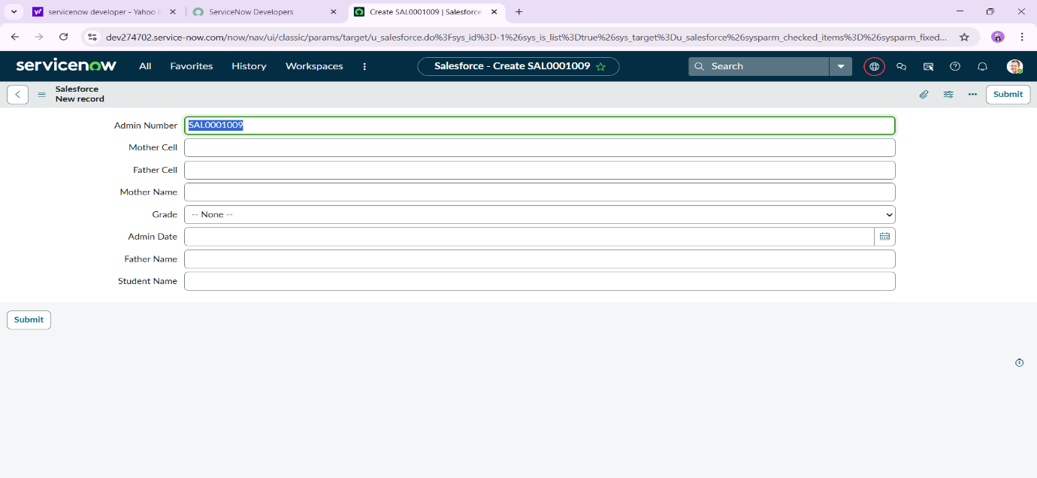

Admission :

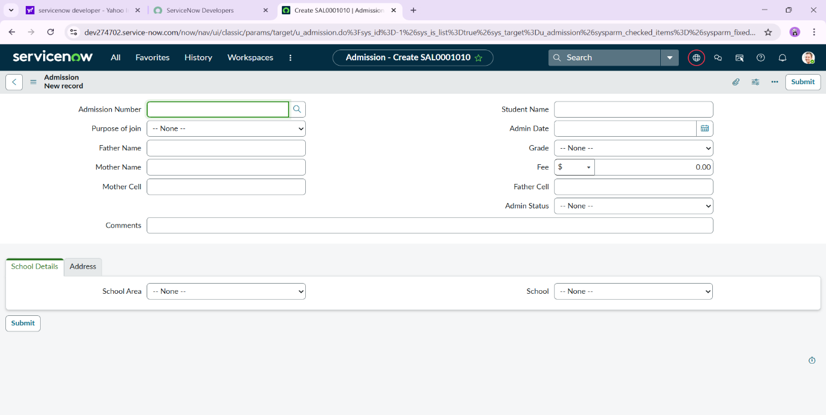

Student Progress:
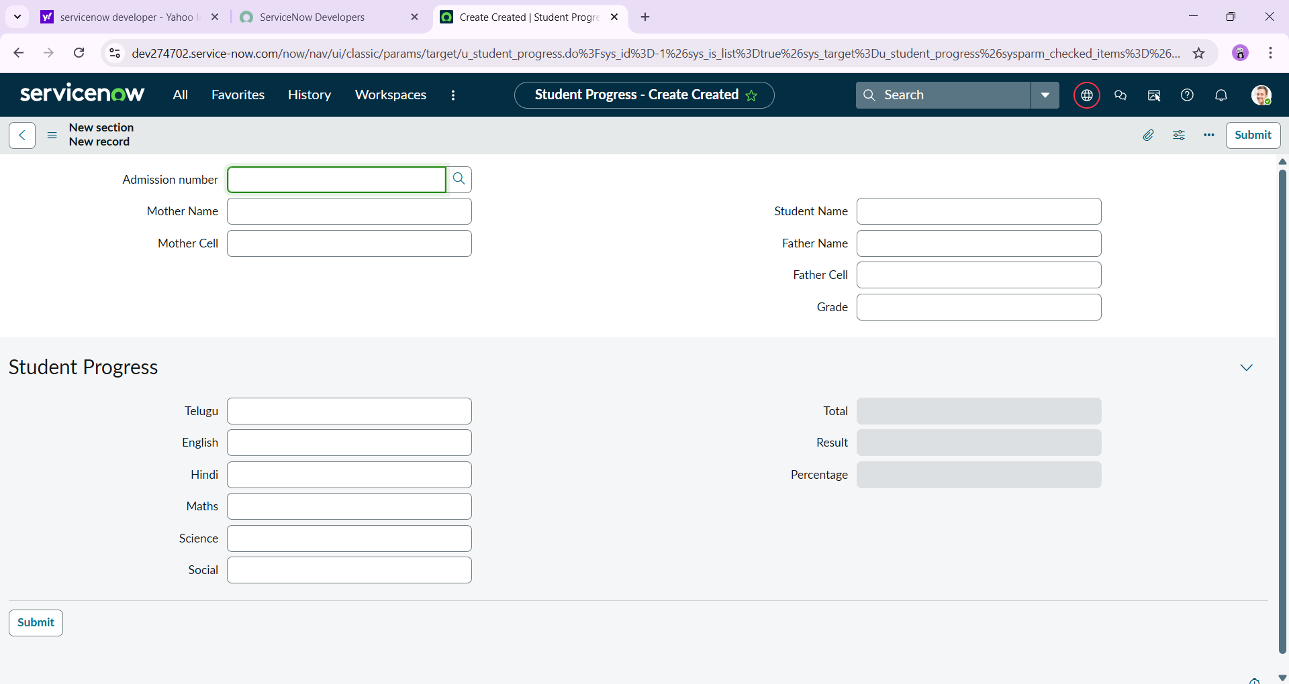

Future Enhancements:
While the current version of the Educational Organization Management System using ServiceNow successfully automates core educational processes such as student admissions, record management, and progress tracking, there are several potential improvements that can make the system more powerful, intelligent, and user-friendly in the future.
- Dashboard and Data Visualization:
A graphical dashboard can be added to visually display real-time analytics, such as total admissions, pass percentages, and student performance trends.
This feature would allow administrators to monitor institutional progress using charts, graphs, and dynamic filters.
- Email and Notification Integration:
Automated email or SMS notifications can be implemented to inform students and parents about admissions, updates, and results.
This would improve communication and ensure timely information delivery.
- Role-Based Access Control:
Introduce multiple user roles such as Admin, Faculty, Student, and Parent, each with limited access rights.
For example, students can view their progress only, while administrators can add or modify all records.
- Attendance Management System:
An additional module can be added to track student attendance.
This can be integrated with the Student Progress table to analyze performance along with attendance consistency.
- Certificate Generation and Printing:
Automated generation of digital certificates (e.g., progress reports or completion certificates) based on Student Progress records.
Certificates can be exported as PDF and downloaded by students or staff.
- Mobile Accessibility:
Develop a mobile-friendly interface or a ServiceNow mobile app extension so that students, faculty, and admins can access the system anytime, anywhere.
- Chatbot and AI Integration:
An AI-powered chatbot can be integrated into the platform to answer basic student or parent queries about admissions, progress, and results, enhancing user support and engagement.
- Integration with External Systems
Future versions can connect ServiceNow with Learning Management Systems (LMS) or CRM platforms for seamless data sharing and broader functionality.
- Data Security and Backup Enhancements
Enable data encryption, regular cloud backups, and user authentication improvements to ensure student and institutional data remain secure at all times.
- Integration with External Systems
Future versions can connect ServiceNow with Learning Management Systems (LMS) or CRM platforms for seamless data sharing and broader functionality.
- Data Security and Backup Enhancement
Enable data encryption, regular cloud backups, and user authentication improvements to ensure student and institutional data remain secure at all times.
- Performance Analytics
Include advanced reporting features that allow teachers and administrators to view performance statistics for departments, subjects, or individual students over time.

Conclusion:
The project “Educational Organization Management System using ServiceNow” successfully demonstrates how automation can transform traditional educational processes into an efficient, reliable, and user-friendly digital system. By implementing modules such as the Salesforce Table, Admission Table, and Student Progress Table, the project achieved its goal of managing student data, admissions, and academic performance in a structured and connected way.
Through ServiceNow’s powerful platform capabilities, manual data entry was replaced with automated workflows, reference links, and form-based records that improved data accuracy and accessibility. The system ensures that administrators and faculty members can easily retrieve information, monitor student performance, and maintain organized records without redundancy.
The testing and output results confirmed that all modules worked seamlessly together, meeting the objectives of automation, accuracy, and transparency. This project not only enhanced understanding of ServiceNow’s application development but also provided hands-on experience in database management, workflow automation, and cloud-based implementation.
Overall, the project provides a scalable foundation that can be further extended with dashboards, notifications, and advanced analytics — paving the way for a complete digital solution for educational organizations.

